**Windows Task Scheduler**

**Steps to Create and Schedule a task in Windows Task Scheduler**

**Step 1:**

In Action Pane -> Create Task....

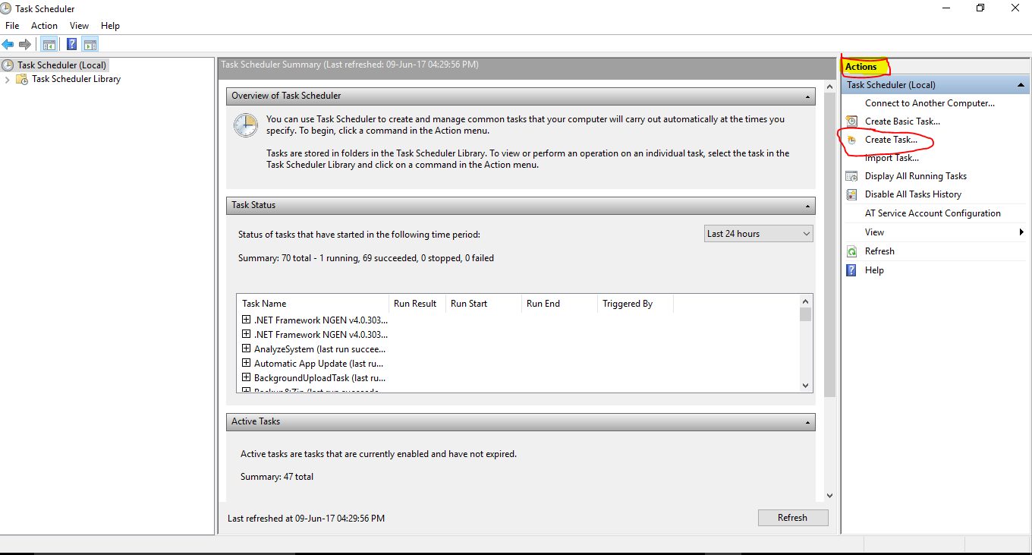

**Step 2:**

1. **General** tab Give the name of the Task

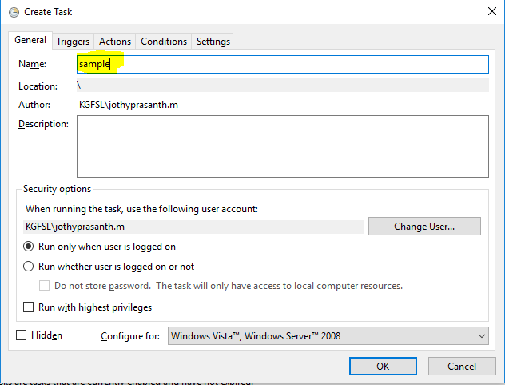

**Step 3:**

2.**Triggers** tab -> New

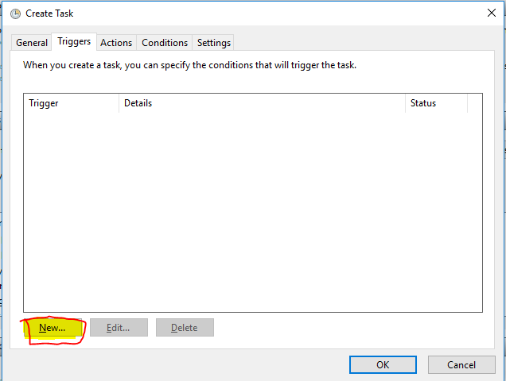

In new window we can schedule the task as per the requirement

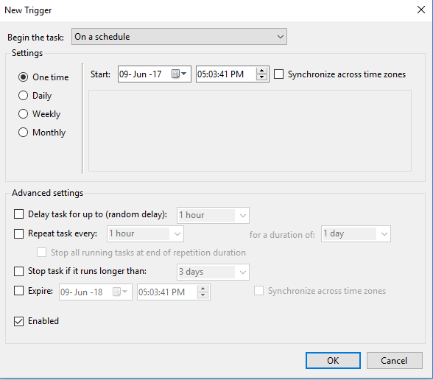

**Step 4:**

3.**Action** tab -> New

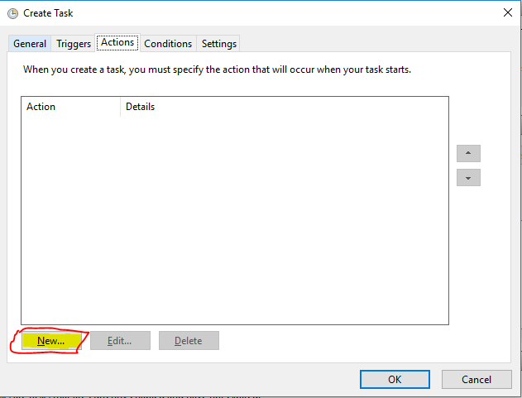

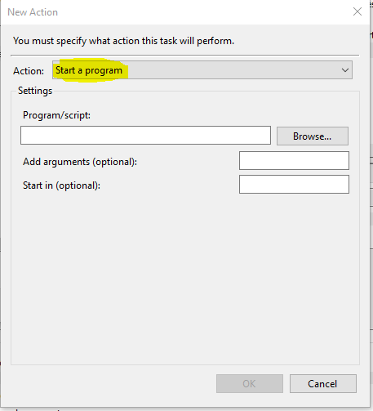

In new Action window the Action sould be “Start the Program”

* In settings Program/Script give the below Command

"C:\Program Files (x86)\UiPath Studio\UiRobot.exe" 🡪 This is the path where the UiRobot was installed.

* In Arguments

/file:"C:\Users\jothyprasanth.m\Documents\UiPath\Axa Task\CompressFolders.xaml" 🡪This is the Path in which uipath file has to Run.

**Step 5:**

4.**Condition** tab

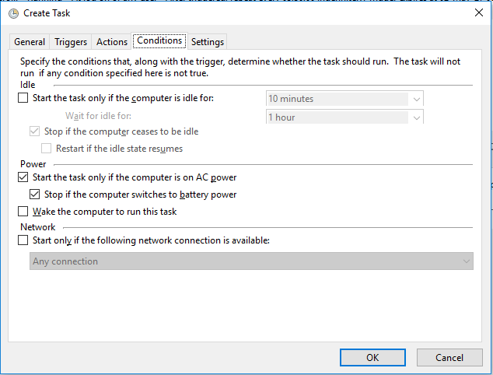

If we need Some Condition to do while running the Task we need to give that other wise click OK

**Step 6:**

5.**Settings** tab

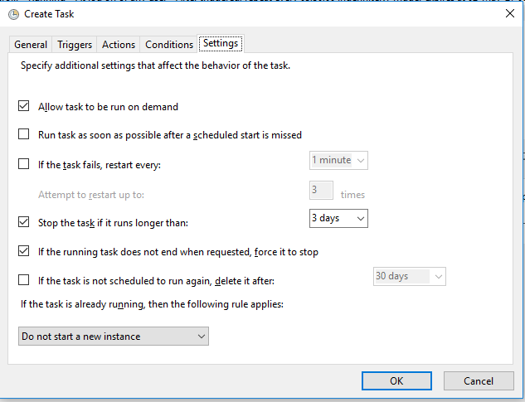

The Settings of the Task is Shows in that Tab. Click OK

**Step 7:**

The Created Task is Shows in Task Schedular.

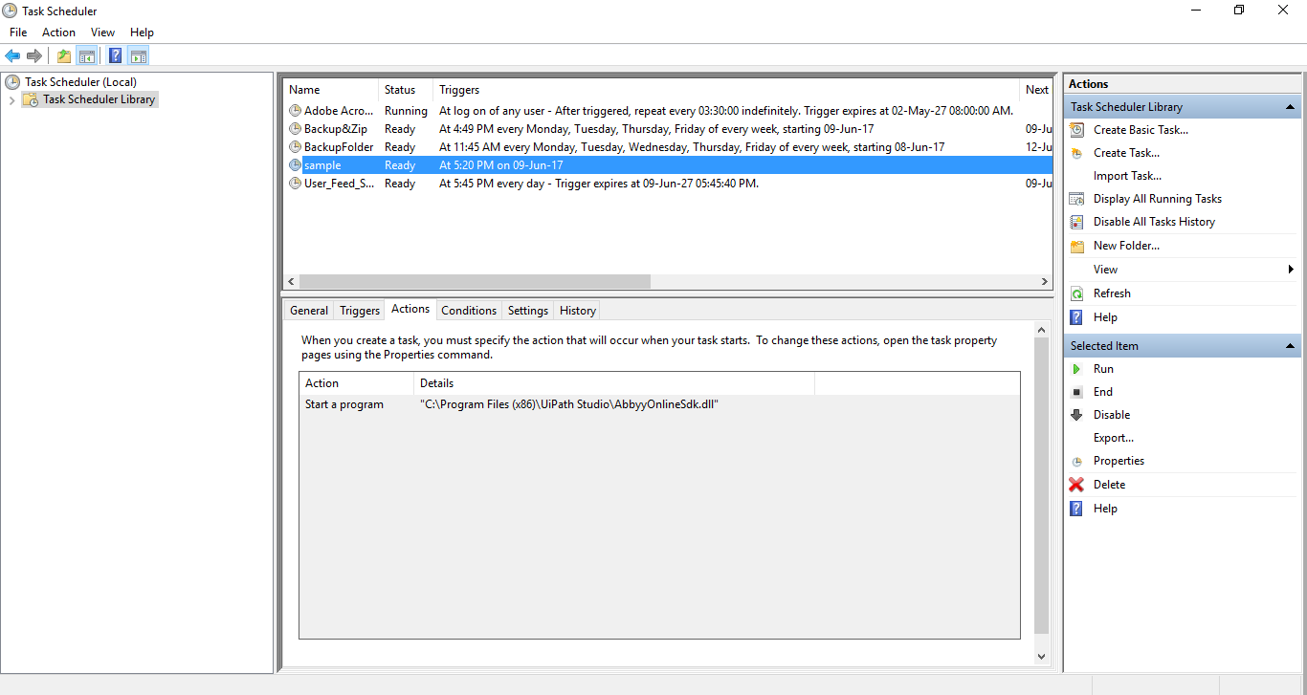

**The task will run automatically once the schedule time is reached.**